**Email Notofication when EC2 stops in production**

Block diagram:

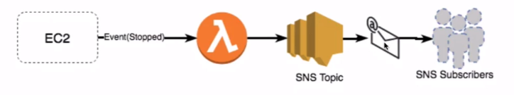

We need following services for this:

1. EC2

2. SNS topic

3. IAM role for lambda to access SNS and cloudwath logs

4. Lambda

5. Cloudwatch Events

Create SNS topic and after creating it, select your sns topic and click on actions>>subscribe to topic.

After this you will be redirected to a screen where in you need to select protocol as **Email** and **Endpoint** as your email id. After this you will get a verification email, verify it and its done.

After this create a role for Lambda by selecting SNS and cloudwatch logs as services for access(please keep in mind we need to create policy first then we need to assign it to role)

Now we need to write python code for lambda. So create a new lambda function, by selecting runtime as **python 3.6,** choose an existing role(created above) and hit create function.

Now write below code in function’s editor.

**import boto3**

**client = boto3.client('sns')**

**def lambda_handler(event, context):**

**topic_arn = '<give your topic arn here>'**

**message = '<type your any notification message here>'**

**client.publish(TopicArn=topic_arn,Message=message)**

Now we need to add trigger to lambda, so add cloudwatch Events as trigger and in configure triggers sections which will be just below on lambda page we need to new rule as shown in screen print below:

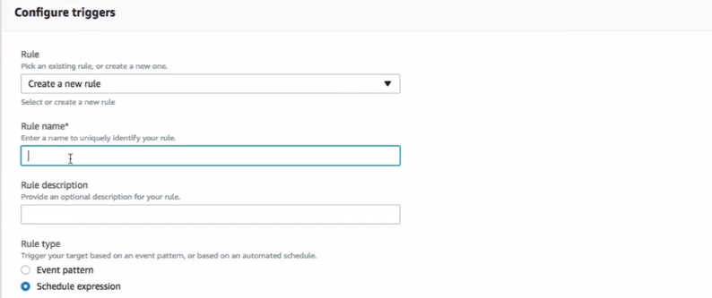

Specify any rule name of your choice, description and select Event pattern.

In Event pattern select **EC2** and **EC2 instance state change notification**, select **Detail** and in detail select **state** as **stopped** and also check on **instances** and provide **instance id** forwhich we want to send notificationshown below: after this click on **add** and **save** this lambda function.

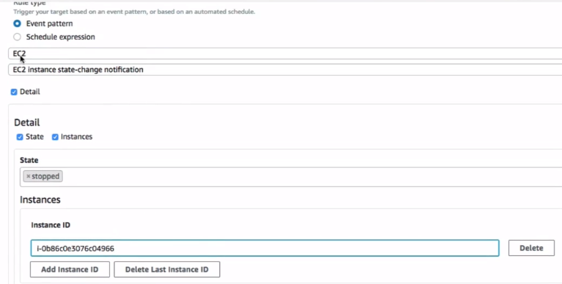

Now test it by manually stopping your EC2 instance and after stopping it you will get the notification.